**MATLAB REPORT**

**NAME: KALLURU DEEKSHITHA REDDY**

**REG.NO.: 20BCI7189**

**TOPIC DATE**

**MATLAB ONRAMP 01.01.2021**

**1. FLOW CONTROL &**

**CONDITIONAL STATEMENTS 11.01.2021**

**2. APPLICATION OF DERIVATIVES 17.01.2021**

**3. APPLICATION OF INTEGRALS 18.01.2021**

**4.** **VECTOR INTEGRALS 21.01.2021**

**5. APPLICATION OF VECTOR**

**INTEGRALS 22.01.2021**

**6. SOLVING DIFFERENTIAL**

**EQUATIONS 28.01.2021**

**7. SOLVING ODE’s USING**

**LAPLACE TRANSFORM 29.01.2021**

1. **MATLAB ONRAMP CERTIFICATE:**



**EXPERIMENT NO. 1**

**FLOW CONTROL AND CONDITIONAL STATEMENTS**

Q1. Plot a circle of given radius with center (h, k). Input the numerical values for h, k and r.

% Circle equation: (x-h)^2 + (y-k)^2 = r^2

% Center: (h,k) Radius: r

h = 1;

k = 1;

r = 1;

xmin = h - r;

xmax = h + r;

x_res = 1e-3;

X = xmin:x_res:xmax;

N = length(X);

x = [X flip(X)];

ytemp1 = zeros(1,N);

ytemp2 = zeros(1,N);

for i = 1:1:N

square = sqrt(r^2 - X(i)^2 + 2*X(i)*h - h^2);

ytemp1(i) = k - square;

ytemp2(N+1-i) = k + square;

end

y = [ytemp1 ytemp2];

c = 1.5;

figure(1)

plot(x,y)

axis([h-c*r h+c*r k-c*r k+c*r]);

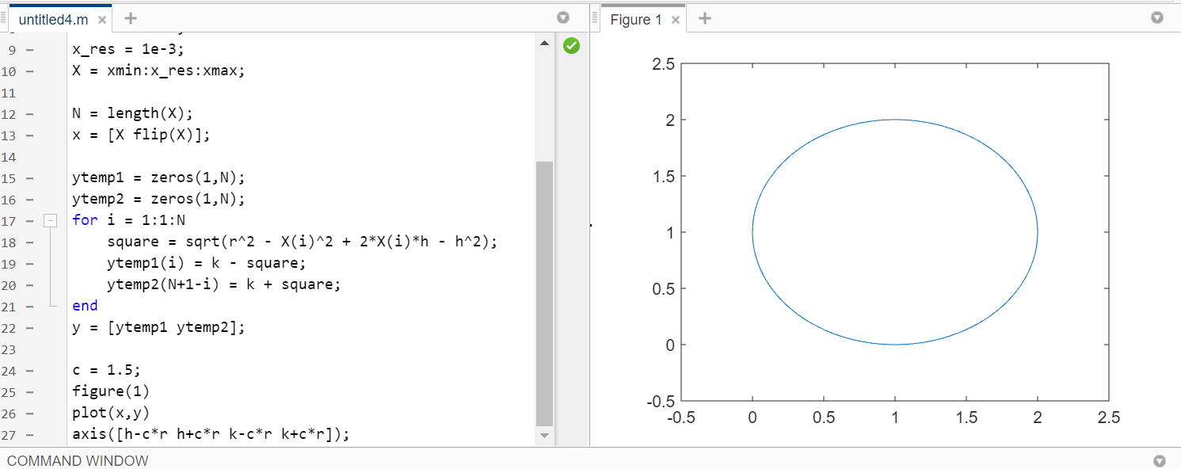

Q2. Write a matlab code to print your name if the last two digits of your roll number form an even number, otherwise plot a circle centered at origin having radius as the last two digits of your roll number.

% Circle equation: (x-h)^2 + (y-k)^2 = r^2

% Center: (h,k) Radius: r

h = 0;

k = 0;

r = 89;

xmin = h - r;

xmax = h + r;

x_res = 1e-3;

X = xmin:x_res:xmax;

N = length(X);

x = [X flip(X)];

ytemp1 = zeros(1,N);

ytemp2 = zeros(1,N);

for i = 1:1:N

square = sqrt(r^2 - X(i)^2 + 2*X(i)*h - h^2);

ytemp1(i) = k - square;

ytemp2(N+1-i) = k + square;

end

y = [ytemp1 ytemp2];

c = 1.5;

figure(1)

plot(x,y)

axis([h-c*r h+c*r k-c*r k+c*r]);

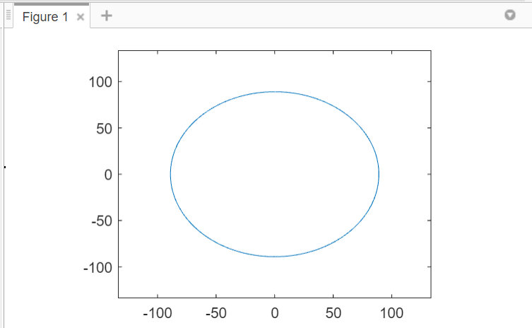

**EXPERIMENT NO.: 2**

**APPLICATIONS TO DERIVATIVES**

**Question 1:** A box with an open top is to be constructed from a rectangular piece of cardboard with dimensions 12 in. by 20 in. by cutting out equal squares of side x at each corner and then folding up the sides as in the figure. Find x so that the volume is maximum.

**CODE :**

%clc

%clear all

syms x

f=x*(71-2*x)*(89-2*x);

df=diff(f);

roots = solve(df==0);

ddf=diff(df);

ddfval=subs(ddf, x, roots);

for i=1:length(ddfval)

if ddfval(i)<0

fprintf('f is maximum')

xmaxvalue=double(roots(i))

fmax=subs(f, x, roots(i))

maxvolume=double(fmax)

else

fprintf('f is minimum')

xminvalue=double(roots(i))

fmin=subs(f, x, roots(i))

minvolume=double(fmin)

end

end

>> Exp_2a

f is maximum

xmaxvalue =

13.0826

**OUTPUT :**

fmax =

-(6643^(1/2)/3 + 53/3)*(6643 ^(1/2)/6 + 80/3)*(6643 ^(1/2)/3 - 107/3)

maxvolume =

3.6856e+04

f is minimum

xminvalue =

3.6856e+04

fmin =

(4381^(1/2)/3 - 49/3)*(4381^(1/2)/3 - 82/3)*(4381^(1/2)/6 + 131/6)

minvolume =

-992.4277

>>

**Question 2 :**  An open rectangular box with the square base is to be made from 48ft^2 of material. What dimensions will result in a box with the largest possible volume?

clc

clear all

syms x y L;

f=(x^2)*y;

diff_f=gradient(f, [x, y]);

fx=diff_f(1);

fy=diff_f(2);

g=(x^2+4*x*y)-67;

diff_g=L*gradient(g, [x, y]);

gx=diff_g(1);

gy=diff_g(2);

eqns=[fx-gx==0,fy-gy==0,g==0];

vars=[x y L]

[sol_x, sol_y, sol_L] = solve(eqns, vars);

xyL_Values= [sol_x(:), sol_y(:), sol_L(:)]

[m,n]=size(xyL_Values);

for i=1:m

result(i)=subs(f,[x,y,L],xyL_Values(i,:))

end

result;

f_min=min(result);

ind_fmin=find(result==f_min);

f_max=max(result)

ind_fmax=find(result==f_max);

mvar=xyL_Values(ind_fmax,:)

vars =

[x, y, L]

xyL_Values =

[-201^(1/2)/3, -201^(1/2)/6, -201^(1/2)/12]

[ 201^(1/2)/3, 201^(1/2)/6, 201^(1/2)/12]

result =

-(67*201^(1/2))/18

result =

[-(67*201^(1/2))/18, (67*201^(1/2))/18]

f_max =

(67*201^(1/2))/18

mvar =

[201^(1/2)/3, 201^(1/2)/6, 201^(1/2)/12]

>>

**EXPERIMENT NO. : 3**

**Application to Integrals**

Q1. Find the mass of a plate bounded by 𝑦 = 𝑥 and 𝑥 = 1, with density µ(𝑥, 𝑦) = 3 − 𝑥 − 𝑦. Print the output with your name and roll number.

clc

clear all

syms x y

fprintf('7189 Deekshitha')

int(int(3-x-y,x,y,1),y,0,1)

7189 Deekshitha

ans =

1

>>

Q2. Find the volume of the region D enclosed by the surfaces 𝑧 = 𝑥 2 +3𝑦 2 and 𝑧 = 8 − 𝑥 2 − 𝑦 2 .

clc

clear all

syms x y z

fprintf('7189 Deekshitha')

int(int(int(1,z,(x^2)+3*(y^2),8-(x^2)-(y^2)),...

x,-sqrt(4-2*(y^2)),sqrt(4-2*(y^2))),y,-sqrt(2),sqrt(2))

7189 Deekshitha

ans =

8*pi*2^(1/2)

>>

Q3. Find average value of 𝐹(𝑥, 𝑦, 𝑧) = 𝑥𝑦𝑧 throughout the cubical region D bounded by the coordinate planes 𝑥 = 2, 𝑦 = 2, and 𝑧 = 2 in the first octant.

clc

clear all

syms x y z xyz

fprintf('7189 Deekshitha’)

vol=int(int(int(1,z,0,2),y,0,2),x,0,2)

avg=(1/vol)*int(int(int(x*y*z,z,0,2),y,0,2),x,0,2)

7189 Deekshitha

vol =

8

avg =

1

>>

**Experiment No. 4**

**Vector Calculus**

Q1. Find the gradient of the function 𝑓 = 𝑥𝑦𝑧 and curl and divergence of vector field 𝑭 = 𝑥 2𝑦𝒊 + 𝑦𝒋 + 𝑥𝑦𝒌.

clc

clear all

syms x y z

f=x*y*z;

F=[(x^2)*y,y,y*z];

vars=[x, y, z];

fprintf('7189 Deekshitha')

grad=gradient(f, vars)

divf=divergence(F, vars)

curlf=curl(F, vars)

7189 Deekshitha

grad =

y*z

x*z

x*y

divf =

y + 2*x*y + 1

curlf =

z

0

-x^2

>>

Q2. Find the directional derivative of the function 𝑓 = 𝑥 cos(𝑦𝑧) at point (−1,2,1) in the direction of the vector, 2𝑖 + 𝑗 + 3𝑘. Print the output with your roll number and name.

clc

clear all

syms x y z

f=x*cos(y*z);

vars=[x, y, z];

P=[-1,2,1];

u=[2,1,3];

norm(u);

unitu =u./norm(u);

fprintf('7189 Deekshitha')

grad = gradient(f, vars)

gradval=subs(grad, vars, P);

DirDer = double(dot(gradval,unitu))

20BCD7160 Prathapani Satwika

grad =

cos(y*z)

-x*z*sin(y*z)

-x*y*sin(y*z)

DirDer =

1.4787

>>

Q3. Draw the two dimensional vector field for the vector 𝑥 2𝑦𝒊 + 𝑥𝑦𝒋.

clc

clear all

syms x y

f1 = inline((x^2)*y,'x','y');

f2 = inline(x*y,'x','y');

x = linspace(-1, 1, 10);

y = x;

[X,Y] = meshgrid(x,y);

U = f1(X,Y);

V = f2(X,Y);

quiver(X,Y,U,V,1)

view(-30,60);

axis on

xlabel('x')

ylabel('y')

title('7189 Deekshitha')

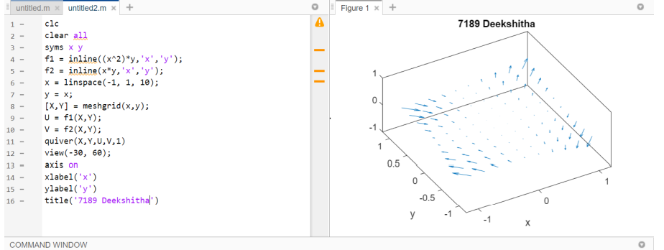

**Experiment No. 5**

**Application to Vector Integrals**

Q1. Integrate 𝑓 𝑥, 𝑦, 𝑧 = 𝑥 − 3𝑦 2 + 𝑧 over the line segment 𝐶 joining the origin to

the point (1, 1, 1).

clc

clear all

syms x y z t

f=x-3*(y^2)+z;

var=[x,y,z];

Par=[t,t,t];

F=subs(f,var,Par);

dr=[diff(Par(1),t),diff(Par(2),t),diff(Par(3),t)];

modr=norm(dr);

I = int(F*modr,t,0,1);

fprintf('7189 Deekshitha \n')

disp('Line integral along the given curve is')

disp(I)

7189 Deekshitha

Line integral along the given curve is

0

>>

Q2. Evaluate the line integral of 𝑭 (𝑥, 𝑦, 𝑧 ) = 𝑧𝒊 + 𝑥𝑦𝒋 − 𝑦 2𝒌 along the curve 𝐶 given by 𝒓 𝑡 = 𝑡 2 𝒊 + 𝑡𝒋 + 𝑡 𝒌, 0 ≤ 𝑡 ≤ 1.

clc

clear all

syms t

x = t^2;

y = t;

z = sqrt(t);

f=[z,x*y,-(y^2)];

r = [x,y,z];

dr = [diff(r(1),t),diff(r(2),t),diff(r(3),t)];

F = dot(f,dr);

I = int(F,t,0,1);

fprintf('7189 Deekshitha \n')

disp('Line integral along the given curve is')

disp(I)

COMMAND WINDOW:

7189 Deekshitha   
Line integral along the given curve is  
17/20

**Experiment No. 6**

**Solving Differential Equations**

Q1.

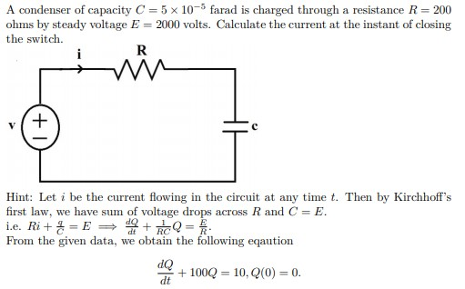

clc

clear all

syms Q(t)

ode=diff(Q,t,1)+100*Q==10;

cond1 = Q(0) == 0;

fprintf('7189 Deekshitha')

QSol(t)=dsolve(ode,cond1)

current=diff(QSol(t))

**7189 Deekshitha**

**QSol(t) =**

**1/10 - exp(-100*t)/10**

**current =**

**10*exp(-100*t)**

**>>**

**Q2.**

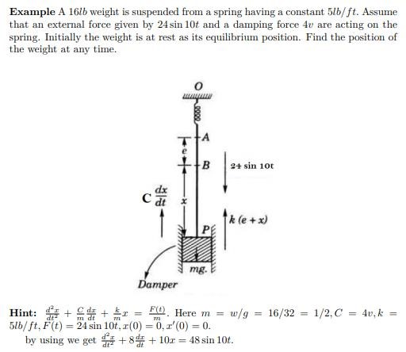

clc

clear all

syms x(t)

ode=diff(x,t,2) + 8*diff(x,t,1) + 10*x == 48*sin(10*t);

m = diff(x,t,1);

cond1 = x(0)==0;

cond2 = m(0)==0;

Array = [cond1, cond2];

fprintf('7189 Deekshitha')

position(t) = dsolve(ode,Array)

7189 Deekshitha

position(t) =

(4*6^(1/2)*exp(4*t + 6^(1/2)*t)*exp(-t*(6^(1/2) + 4))*(10*cos(10*t) - sin(10*t)*(6^(1/2) + 4)))/((6^(1/2) + 4)^2 + 100) - (4*6^(1/2)*exp(4*t - 6^(1/2)*t)*exp(t*(6^(1/2) - 4))*(10*cos(10*t) + sin(10*t)*(6^(1/2) - 4)))/((6^(1/2) - 4)^2 + 100) - (20*6^(1/2)*exp(t*(6^(1/2) - 4)))/(4*6^(1/2) - 61) + (20*6^(1/2)*exp(-t*(6^(1/2) + 4))*(488*6^(1/2) - 3817))/((4*6^(1/2) - 61)^2*(4*6^(1/2) + 61))

**>>**

# Experiment No. 7

# Solving ODEs using Laplace Transform

Q1. Find the Laplace Transform of the following functions

a). 𝑓 𝑥 = 1 − 𝑥 + 2𝑥 2

b). 𝑓 𝑥 = 4𝑒 −3𝑡 − 10sin 2

clc

clear all

syms f1(t) f2(t) s a

f1(t)= 1-t+2*(t^2);

f2(t)= 4*exp(-3*t)-10*sin(2*t);

fprintf('7189 Deekshitha')

F1 = laplace(f1,t,s)

F2 = laplace(f2,t,s)

7189 Deekshitha

F1 =

(s - 1)/s^2 + 4/s^3

F2 =

4/(s + 3) - 20/(s^2 + 4)

>>

Q2. Solve the ordinary differential equation 𝑦 ′′ + 2𝑦 ′ = 8𝑡, 𝑦 0 = 1, 𝑦 ′ 0 = 0, using Laplace transform.

clc

clear all

syms t s Y y(t) Dy(t)

Df=diff(y(t),t,1);

DDf=diff(y(t),t,2);

Eqn=DDf+2*Df==8*t;

LEQN=laplace(Eqn,t,s);

LT_Y=subs(LEQN,laplace(y,t,s),Y);

LT_Y=subs(LT_Y, y(0), 1);

LT_Y=subs(LT_Y, subs(diff(y(t), t), t, 0), 0);

ys=solve(LT_Y,Y);

fprintf('7189 Deekshitha');

y=ilaplace(ys,s,t)

7189 Deekshitha

y =

2*t^2 - exp(-2*t) - 2*t + 2

>>

Q3. Solve the equation y’’+ 16y = 16sin(2t) with the initial conditions that y(0) = 1, and y ‘ (0) = 0.

clc

clear all

syms y(t) t s Y Dy(t)

Df=diff(y(t),t,1);

DDf=diff(y(t),t,2);

Eqn=DDf+16*y==16*sin(2*t);

LEQN=laplace(Eqn,t,s);

LT_Y=subs(LEQN,laplace(y,t,s),Y);

LT_Y=subs(LT_Y,y(0),1);

LT_Y= subs(LT_Y,subs(diff(y(t),t),t,0),0);

ys=solve(LT_Y,Y);

fprintf('7189 Deekshitha')

y = laplace(ys,s,t)

7189 Deekshitha   
y =  
   
cos(4*t) + (4*sin(2*t))/3 – (2*sin(4*t))/3

>>